Deerwalk Institute of Technology
Sifal, Kathmandu

Artificial Intelligence Practical - 7

Submitted By: Submitted To:
Name: Sagar Giri Sudan Prajapati
Roll No: 205
Section: A

Date: 22 April 2015
Tracing in Prolog

SWI Prolog allows us to trace the route that Prolog takes through a program when looking for a solution to a particular query. There are 2 ways to do this, the graphical and the non-graphical trace. Both yield up the same information but do so in different ways.

Task 1:

adminworker(black).
adminworker(white).
officejunior(green).
manager(brown).
manager(grey).
supervise(X,Y):-adminworker(X),adminworker(Y).
supervise(X,Y):-adminworker(X),officejunior(Y).
supervise(X,Y):-manager(X),officejunior(Y).

Tracing Output:
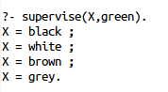

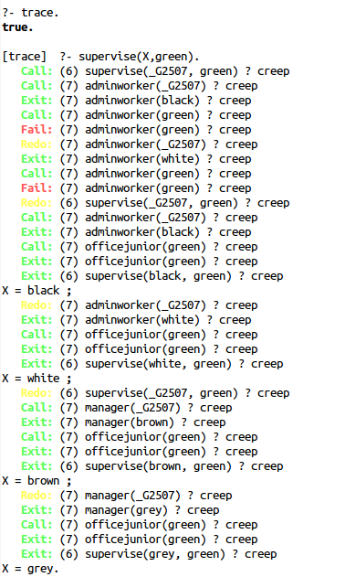

Task 2:
kicking(malfoy,harry).
eating(dudley).

happy(aunt_petunia):-happy(dudley).
happy(uncle_vernon):-happy(dudley),unhappy(harry).
happy(dudley):-kicking(dudley,harry).
happy(dudley):-eating(dudley).

Trace Output:
